
SDK 4.5.1

Semantic SDK - System Use Cases

11/23/2012
Rev 0.1

Required Approvals:
Author of this Revision (SME): | Prasad Konka
System Engineer: | Prasad Konka
Program Sponsor: | Robert Shirley
Project Manager: | Zhengwu Lu
 | Print Name |  | Signature |  | Date

This document and the technologies it describes are the collective work product of members of CBIIT staff and stakeholder community.
The mission of CBIIT is to steward access to digital capabilities essential to enhancing researchers’ capacity to share and utilize biomedical information, ultimately improving patient outcomes.
In partnership with the community, the goals of are to:
- Connect scientists and practitioners through a shareable and interoperable infrastructure
- Develop standard rules and a common language to easily share information
- Build or adapt tools for collecting, analyzing, integrating, and disseminating information associated with medical research and care.

Document Revisions:
Revision | Revised By | Reason for Update | Date
0.1 | Prasad Konka | Initial Draft | 11/23/12

Table of Contents
1. This Document 4
1.1. SDK 4
1.2. caDSR 4
1.3. Semantic SDK - Purpose & Scope 5
2. Design Overview 5
3. Use Cases 7
3.1. Data with Metadata 7
3.1.1. Extract Metadata from model 7
3.1.2. Inject Metadata 8
3.1.3. Enable or disable Metadata at runtime 9
3.1.4. Display Metadata on Web Interface 10
4. References 12

This Document

SDK
The National Cancer Institute (NCI) Center for Biomedical Informatics and Information Technology (CBIIT) provides biomedical informatics support and integration capabilities to the cancer research community. CBIIT has created the caCORE Software Development Kit or caCORE SDK, a data management framework designed for researchers who need to be able to navigate through a large number of data sources. caCORE SDK is CBIIT’s platform for data management and semantic integration, built using formal techniques from the software engineering and computer science communities.
By providing a common data management framework, caCORE SDK helps streamline the informatics development throughout academic, government and private research labs and clinics. A caCORE SDK generated system is built on the principles of Model Driven Architecture (MDA) and specifically Model Driven Development (MDD) and n-tier architecture and consistent API. Model Driven Architecture (MDA) and MDD is a software development practice that uses a structured modeling language to describe the requirements, objects, and interactions of a data system prior to its construction. The use of MDA and n-tier architecture, both standard software engineering practices, allows for easy access to data, particularly by other applications.
Users of the caCORE SDK benefit in numerous ways. The primary benefits of using the caCORE SDK includes:
- Consistent UML representation of the data – Users of the caCORE SDK are required to represent their data in UML format.
- Rapid data service generation – The SDK can data service APIs quickly from the UML model.
- Uniform way to access data – SDK-generated systems provide uniform access to the data stores.
- Query using information model – SDK-generated systems allow queries to be written in various ways including using Query-By-Example.
- Integrated Security with CSM – SDK generated system can be made secured with CSM through authentication and authorization.

caDSR
The caDSR is a metadata repository conforming implementation of the ISO/IEC 11179 metadata standard with NCI extensions. The caDSR provides different tools to annotate a model with standardized and registered metadata. The caDSR is a library of reusable metadata.

Semantic SDK - Purpose & Scope

SDK generated system provides syntactically interoperable interfaces to share data in XML format. SDK integration with the caDSR repository and annotated models presents opportunity to enable semantic capability within SDK generated data service. Providing metadata of the data that is being queried with SDK data service would facilitate data processing and effective electronic data interchange between applications.

Annotated model with metadata information will be parsed by SDK code generation component to extract metadata from the model and it will be used by runtime component to inject it into the data that is being queried. The resulting data will have metadata (semantics) along with query results.

SDK provides different convenient ways to query data from a connected data store. SDK Semantic query will be supported on the data that is represented in XML format only. This would be supported by RESTful interface only.

Design Overview
The caCORE SDK has two modules:
- Code Generation, which accepts a UML model as input and produces java classes and other artifacts such as a standard XML Schema (xsd) that can be used by standard client APIs
- Middleware, that provides the actual infrastructure including the server and standard client APIs to provide access to the underlying data system through n-tier architecture

When the caCORE SDK-generated system is combined with controlled vocabularies and registered metadata, the resulting software system, called a "caCORE-like" system, is "semantically” integrated. The caDSR metadata provides the meaning of data field, the data type, representation and the meaning through its CDE(common data element). A data element is a unique pairing of a data element concept and a value domain. It represents conceptual entity about which data is being collected and physical representation.

A caDSR Data Element is formed when a Concept takes on a specific representation
- Data Element Concept = Object Class (thing) + Property (characteristic)
- Value Domain = Representation such as its Data Type, Unit of Measure, Minimum Length, Maximum Length, etc. with or without a specific list of values (enumerated, non-enumerated)
- Data Element = Data Element Concept + Value Domain
Each Data Element Concept + Value Domain pair is Unique. Within the framework of a UML Model, CDEs are mapped to the UML attribute level and administered through caDSR tools. Each Administered Item has a Public ID and Version number in the caDSR. Public ID and Version number on each administered UML attribute is represented through custom tags CADSR_DE_ID and CADSR_DE_VERSION in a model.

During code generation, SDK will parse custom tags on each UML attribute that was annotated and added to a registered model with caDSR. Code generator will store parsed values into a file called <project>_metadata.xml. This xml will contain project name, full class name, attributes associated with CADSR_DE_ID and CADSR_DE_VERSION values.

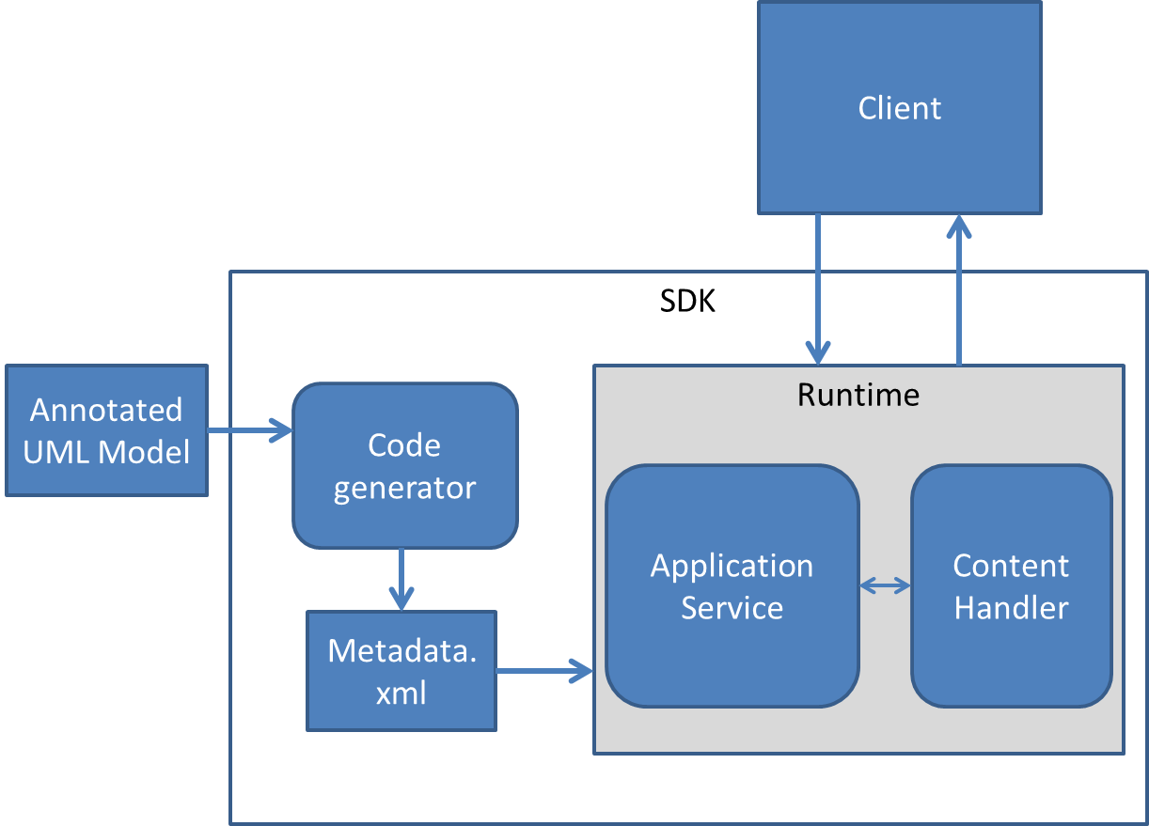

Example:
<Metadata>
<class name=”gov.nih.nci.domain.abc”>
<attribute name=”ID”>
<tag name=”CADSR_DE_ID” value=”211223”>
<tag name=”CADSR_DE_VERSION” value=”1.2”>
<attribute>
</class>
</Metadata>

When a client query for an object, corresponding metadata of the object from the model will be injected and returned as part of XML representation of the object. This way, the data that is returned by SDK service includes semantic information and thereby allowing researchers to look for semantic metadata along with actual research data, hence adding interoperability potentials between applications.

When a client application makes a request for a domain object data, SDK data service would return XML in the following manner.

Ex:
<Person firstName=”John” lastName=”Doe”>
</Person>

With metadata injected, SDK data service would return XML in the following manner. Metadata is treated as attributes for each element.
<Person>
<firstName PublicID=”12345” Version=”1.2”>John</firstName>
<lastName PublicID=”12345” Version=”1.2”>Doe</lastName>
</Person>

Use Cases
SDK is a toolkit that lets users of it to create a runtime system. The users of the caCORE SDK are required to represent their data in UML format to generate the runtime system. SDK generated runtime system let other applications or user to query data using its consistent API or standardized interfaces.

Data with Metadata
Metadata describes characteristics of the data. The purpose of using metadata is to get semantic meaning along with data value. This would enable data processing and effective data interchange.

Extract Metadata from model
SDK generated system is built on the principles of Model Driven Architecture (MDA) and specifically Model Driven Development (MDD). SDK supports reading UML models generated with EA and ArgoUML to generate different artifacts.
Storyboard
- Set up SDK codegen properties to use annotated UML model
- Run SDK codegen to generate metadata xml
Pre-conditionS

UML Model followed SDK modeling practices to model information, data models and their mappings.
UML Model attributes have custom tags CADSR_DE_ID, CADSR_DE_VERSION and their values are set.
Values set for CADSR_DE_ID, CADSR_DE_VERSION exists in caDSR repository.
FLOW OF EVENTS
- User run SDK code generation with input as UML model
ALTERNATE FLOW OF EVENTS
- Steps…
Post-conditionS
- SDK code generator generates <project>_metadata.xml
EXCEPTION FLOW OF EVENTS
- Steps…

Inject Metadata
Data shared by SDK generated data service doesn’t provide any metadata about the data. If the data is being represented in XML format, XSD can be helpful to find syntactical information about the data. The semantic information that represents meaning of the data would be missing to enable electronic data exchange and data processing.
Storyboard
- Generate deployable SDK RESTful application and deploy it into JBoss or Tomcat container
- Use RESTful interface to query domain object(s)
- Runtime system injects metadata into resulted data and returns data with metadata in XML representation
Pre-conditionS

UML Model followed SDK modeling practices to model information, data models and their mappings.
UML Model attributes have custom tags CADSR_DE_ID, CADSR_DE_VERSION and their values are set.
Values set for CADSR_DE_ID, CADSR_DE_VERSION exists in caDSR repository.
Set up SDK codegen properties to use annotated model
Run SDK codegen to generate metadata xml

FLOW OF EVENTS
- User runs SDK build script to generate deployable RESTful application
- User deploys generated application into Tomcat or JBoss container
- User runs RESTful GET operation to query a domain object
- Runtime system returns data with metadata in XML representation
ALTERNATE FLOW OF EVENTS
- Steps…
Post-conditionS
Runtime system returns data with metadata in XML representation
EXCEPTION FLOW OF EVENTS
- Steps…

Enable or disable Metadata at runtime
SDK runtime will provide a configuration property to enable or disable injecting metadata into query data.
Storyboard
- Set up SDK codegen to use annotated model to extract metadata
- Run SDK codegen to generate metadata xml
- Set runtime property to disable injecting metadata
- Run SDK runtime system to query domain objects via RESTful interface
- Runtime system returns data without metadata as XML

Pre-conditionS

UML Model followed SDK modeling practices to model information, data models and their mappings.
UML Model attributes have custom tags CADSR_DE_ID, CADSR_DE_VERSION and their values are set.
Values set for CADSR_DE_ID, CADSR_DE_VERSION exists in caDSR repository.
FLOW OF EVENTS
- User run SDK code generation with input as UML model
- SDK code generator generates project_metadata.xml
- User run SDK to generate deployable application
- User deploys the application into JBoss or Tomcat container
- User query for a domain object through RESTful GET operation
- User gets resulted data without metadata included
ALTERNATE FLOW OF EVENTS
- Steps…
Post-conditionS
- Fill in
EXCEPTION FLOW OF EVENTS
- Steps…

Display Metadata on Web Interface
SDK generated RESTful web interface will display any available metadata by clicking on column header.
Storyboard
  - Set up SDK codegen to use annotated model to extract metadata
  - Run SDK codegen to generate metadata xml
  - Set runtime property to enable injecting metadata and enable generating RESTful Interface
  - Run SDK runtime system to query domain objects via RESTful interface
  - Click on column header to see metadata in a popup window

Pre-conditionS

UML Model followed SDK modeling practices to model information, data models and their mappings.
UML Model attributes have custom tags CADSR_DE_ID, CADSR_DE_VERSION and their values are set.
Values set for CADSR_DE_ID, CADSR_DE_VERSION exists in caDSR repository.

FLOW OF EVENTS
  - User run SDK code generation with input as UML model
  - SDK code generator generates project_metadata.xml
  - User run SDK to generate deployable application
  - User deploys the application into JBoss or Tomcat container
  - User query for a domain object through RESTful web interface
  - User clicks on column header to see attribute metadata
ALTERNATE FLOW OF EVENTS
- Steps…
Post-conditionS
- Fill in
EXCEPTION FLOW OF EVENTS
- Steps…

References

